Customer Requirements Specification
(Lastenheft)

(TINF19C, SWE I Praxisprojekt 2020/2021)

Project: PLCopen-Editor

Customer: Rentschler & Holder
Rotebühlplatz 41
70178 Stuttgart

Supplier: Team 1 (Elian Yildirim, Franziska Kopp, Leonie de Santis, Mouaz Tabboush)
Rotebühlplatz 41
70178 Stuttgart

Version | Date | Author | Comment
0.1 | 16.10.2020 | Leonie de Santis | Created
0.2 | 18.10.2020 | Leonie de Santis | Added the goal and product environment
0.3 | 21.10.2020 | Leonie de Santis | Use Cases created and completed with diagrams
0.4 | 24.10.2020 | Leonie de Santis | Added Features and Business processes
0.5 | 28.10.2020 | Leonie de Santis | Added Product Data and Other Product Characteristics
1.0 | 09.11.2020 | Leonie de Santis | Corrections

CONTENTS

1. Goal 3
2. Product Environment 4
3. Product Usage 5
3.1. Business Processes 5
3.1.1. <BP.001>: PLC programming 5
3.2. Use Cases 5
3.2.1. <UC.001> Create PLC program 5
3.2.2. <UC.002> Import File 6
3.2.3. <UC.003> Export File 7

3.3. Features 8
3.3.1. /LF10/ GUI Components 8
3.3.2. /LF20/ Navigation 8
3.3.3. /LF30/ Editor 8
3.3.4. /LF40/ File validation 8
3.3.5. /LF50/ Variables 8
3.3.6. /LF60/ Connections 8
3.3.7. /LF70/ Plausibility check 8
3.3.8. /LF80/ Exporter 9
3.3.9. /LF90/ Error display 9

4. Product Data 10
4.1. /LD10/ PLC 10
4.2. /LD20/ FB 10
4.3. /LD30/ File types 10
5. Other Product Characteristics 11
5.1. /NF10/ Usability 11
5.2. /NF20/ License 11
5.3. System Environment 11
6. References 12

Goal
The goal of this project is to develop a web application which supports the commonly used programming languages of Programmable Logic Controllers (PLC) according to IEC 61131-3 [1]:
- Ladder Logic (LD)
- Function Block Diagram (FBD)
- Instruction List (IL)
- Structured Text (ST)
- Sequential Function Chart (SFC)
The editor of the open source project OpenPLC [2] can be used as a reference. The GUI shall be implemented as a browser based application based on ANGULAR. The editor shall enable the graphical creation of PLC programs and support at least FBD and SFC. All common logic blocks should be provided as graphical library elements which can be dragged into the editing window and linked with each other via their inputs/outputs. The programs should be able to be saved and loaded in the XML-format PLCopen[3] and AutomationML[4].
Optionally, a functional verification of a sample program on a runtime system and an interactive SCADA HMI on a suitable system without hardware I/O, can be performed.

Product Environment
The software is mainly used in automation technology for control and regulation tasks. The programmable logic controller (PLC) represents an open and universal automation solution for almost all industries and applications. The programming languages LD, FBD, IL, ST and SFC are to be supported. Initially, priority is given to the programming languages FBD and SFC.
SFC is a graphical representation for the description of sequential processes. It is often used in a superordinate way to break down a process into manageable units and to describe the control flow between these parts. The steps contained therein can be formulated independently of each other in another language defined in IEC 61131-3. FBD is another graphically oriented programming language for PLC. It works with a list of networks. Each network contains a structure that can contain logical and arithmetic expressions, function block calls, a jump or a return statement.
To exchange programs between development environments, the PLCopen XML and AutomationML formats are used. AutomationML (AML, Automation Markup Language) developed a neutral, XML-based and free standard for representing automation systems as objects. It enables a transfer of technical data. For this purpose already existing formats were adapted and merged in a suitable way. The representation of plant-specific data is possible in general and in particular the plant structure, geometry, kinematics and logical description. PLCopen XML is used for the logical description. PLCopen XML contains all important information about the different PLC programming languages, as well as the program organization units (POU) created by the user, such as functions and function blocks. It also includes graphical information such as the position and the connections.

.

Product Usage
The following business processes, use cases and features shall be supported by the system.

Business Processes

<BP.001>: PLC programming

Triggering Event: | The user opens the GUI and wants to create or upload a PLC program
Result: | The user creates a graphical PLC program. This can be created as FBD or SFC.
Involved Roles: | User and Editor GUI

Use cases
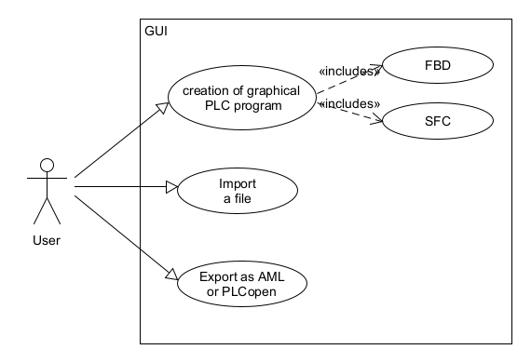
Figure 1: Use Case Overview Diagram

<UC.001> Create PLC program

Related Business Process: | <BP.001>: PLC programming
Use Cases Objective: | User wants to create a graphical PLC program. The User can choose between the programming languages FBD and SFC
System Boundary: | Program itself is the system boundary.
Precondition: | The GUI has to run without errors.
Postcondition on success: | If an error occurs, an easily understandable error message should be communicated.
Involved Roles: | User, Editor
Triggering Event: | User opens the GUI

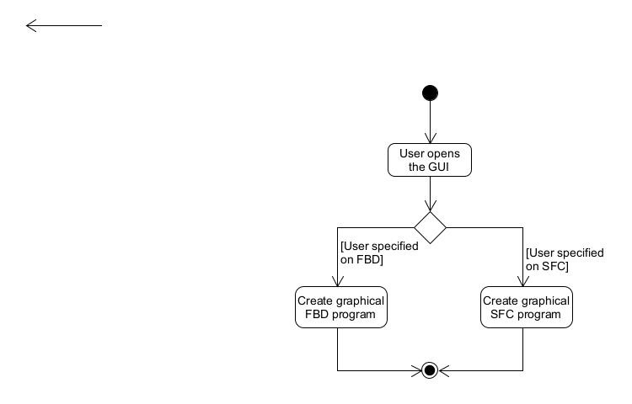
Figure 2: <UC.001> Create PLC program

<UC.002> Import file
Related Business Process: | <BP.001>: PLC programming
Use Cases Objective: | User wants to import an OpenPLC or AutomationML file to load the PLC-program
System Boundary: | Program itself is the system boundary.
Precondition: | Imported file must be valid and without errors.
Postcondition on success: | The PLC program was loaded completely
Involved Roles: | User, PLCopen/AML file, Importer
Triggering Event: | User opens the GUI and want to import a file

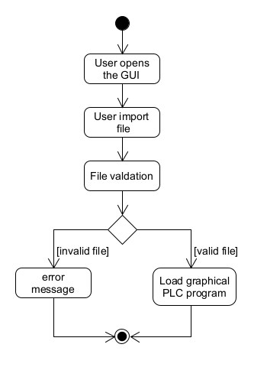
Figure 3: <UC.002> Import file

<UC.003> Export as PLCopen or AML
Related Business Process: | <BP.001>: PLC programming
Use Cases Objective: | User want to export the PLC program as PLCopen or AutomationML to exchange their program between development environments
System Boundary: | Program itself is the system boundary.
Precondition: | Created PLC program must be without errors.
Postcondition on success: | The browser shall not be closed until the export is completed
Involved Roles: | PLC program, Exporter
Triggering Event: | User finished the graphical PLC program and decide to save in PLCopen or AutomationML

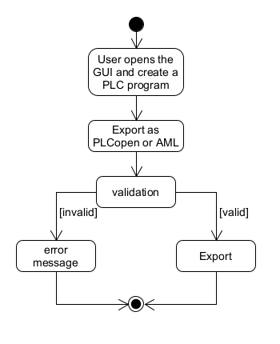
Figure 4: <UC.003> Export as PLCopen or AML

Features
The following functionalities shall be supported by the system.

    - /LF10/ GUI Components
The GUI has a homepage where a new project can be created or loaded. There should also be a project overview where new sections can be added to the project. These sections can then be edited in the editor and filled with blocks or corresponding modules.
    - /LF20/ Navigation
The user should be able to navigate through his project with the help of a navigation bar. There, the user can see the project overview. The user can switch the current location or program.
    - /LF30/ Editor
The editor shall create a graphical PLC program from the imported file. If an error occurs, a corresponding error message should be displayed. If the file is imported completely, the user can edit the PLC program. The supported languages are FBD and SFC.
    - /LF40/ File validation
The File validation shall check if the imported file is convertible and corresponds to the PLCopen XML or AML schema. In case of violation, an error message is displayed and the user is asked to import a new file. If the file is valid, it can be imported.
    - /LF50/ Variables
The input and output variables of function blocks shall be defined.
    - /LF60/ Connections
The user interface offers througt the intention of drag and drop functions a simple and clear editing and creation of the programs with blocks/respective modules. These blocks can be connected to each other at the inputs and outputs.
    - /LF70/ Plausibility check
The plausibility check is intended to check if the PLC program has a complete and correct structure. In case of violation, the user should be informed of his fault. Otherwise, the user can continue or export the program.

    - /LF80/ Exporter
The exporter should save the created PLC program as PLCopen XML or AML file. If an error occurs, a corresponding error message should be displayed. If the export was completed successfully, the web application can be closed or continued. The exported file can be imported into the PLCopen editor or the AutomationML editor.
    - /LF90/ Error Display
The Software shall check if an error has occurred. If an error occurs, the user should receive an appropriate and understandable error message so that the error can be easily corrected.

Product Data

/LD10/ PLC
The editor shall support at least the PLC programming languages FBD and SFC.

/LD20/ FB
The editor shall provide all current logic blocks as graphical library elements. These can be dragged into the editor window and connected to each other at the inputs and outputs.

/LD30/ File Types
The system shall work with the file types, PLCopen XML and AML. It must transfer these files into a graphical PLC program or be able to export a PLC program in one of these file types.

Other Product Characteristics
This section describes the already known non-functional requirements for the product.

/NF10/ Usability
The software should support a graphical user interface. It should be clearly laid out and easy to use so that the user can achieve the objectives effectively, efficiently and satisfactorily.

/NF20/ License
The software shall be published under the MIT license [5].

System Environment
The PLCopen-Editor is a browser-based application and therefore only requires an Internet connection and an installed web browser on your computer to work.

References
[1] http://tiegelkamp.eu/Buch/IEC61131-3JohnTiegelkampDeutschV1.2.pdf
[2] https://www.openplcproject.com/plcopen-editor/
[3] https://plcopen.org/
[4] https://www.automationml.org/
[5] https://opensource.org/licenses/MIT

